Photography – Camera Tools and Functions Study Guide for Test

- Which is the fastest ISO (film speed)? 200 or 3200?

_________________________

- This is the tone (or value) to which all light meters average the light given off by the scene which is being photographed?

_________________________

- This tool indicates how much light is being allowed into the camera based on the current aperture, shutter speed, and ISO settings.

________________________________

- What is a change in an exposure setting, either aperture or shutter speed, that either doubles or halves exposure?

____________________________

- What happens to digital photos the when you shoot on higher ISO settings?

________________________________________________________________

- What controls the duration (time) of an exposure on a camera?

_____________________________________________

- What is the tool that controls the volume of light (the opening) entering the camera during an exposure?

_____________________________________________

- What is another term for aperture?

_____________________________

- Why do smaller aperture numbers (as they are displayed on the camera) represent larger openings?

_____________________________________________________________________

- Describe what is meant by a stop in the realm of photography?

________________________________________________________________________________________________________________________________________________

- Which aperture setting would produce the largest depth of field? f/4 or f/22?

____________________________

- Which aperture setting would produce the shallowest depth of field? f/1.7 or f/8?

____________________________

- Which aperture is most often used for portraits to de-emphasize the background and make the face stand out? f/2.8 or f/16?

___________________________

- Which aperture would be best used to shoot a landscape and get the most of scene in focus with the largest depth of field? f/4 or f/22?

___________________________

- Which shutter speed would best freeze motion? 1/60 or 1/2000?

___________________________

- What is the combined effect of the volume of light striking the light sensitive surface and its duration?

_________________________________

- Which diagram demonstrates how an image is projected inside a camera?
A.
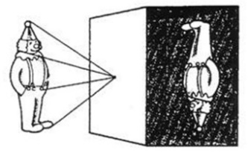

B.
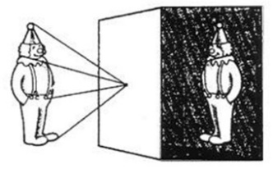

A or B? ___________

- White balance is a function of a digital camera used to __________________________for __________________ colors of light being emitted by __________________ ________________ ________________. In digital photography the term is generally used to describe a function of a digital camera that allows you to _______________________the device to correctly display the color white. Once this ______________________ has been done, the camera should then display ______________ _________________ correctly as well.

- Exposure Bracketing is the process where you shoot the exact same scene at different _______________________ settings.

- What are the three factors that affect depth of field?

________________________________________________________________________
________________________________________________________________________________________________________________________________________________

